|  |
| --- |
|  |

**Games Design Document**

**Game Name**

**Student Name :**

**Dave Mathew Daniel**

**(D025959K)**

|  |  |
| --- | --- |
|  |  |
|  |
|  |  |

**Tables of Contents**

Contents

High Concept: 3

Level Design documentation: 4

Level Design Plans 5

Player Characters, Controls and Abilities 6

Weapons and Pickups 6

Game Conditions 7

Rewards and Progress 7

Enemy Design 8

# High Concept:

* + One line Introduction

The King of all Giants Kronos is on a mission to set things right, He is going to get his revenge on his son Zeus with the help of the god of War Ares and the god of Fire Hephaestus. He soon finds out that he has been betrayed by his son and will reclaim what is his soon enough

* + Theme / Environment / Setting

Island/ Private Beach; Greek Mythology/ Modern time Setting; Beach Party.

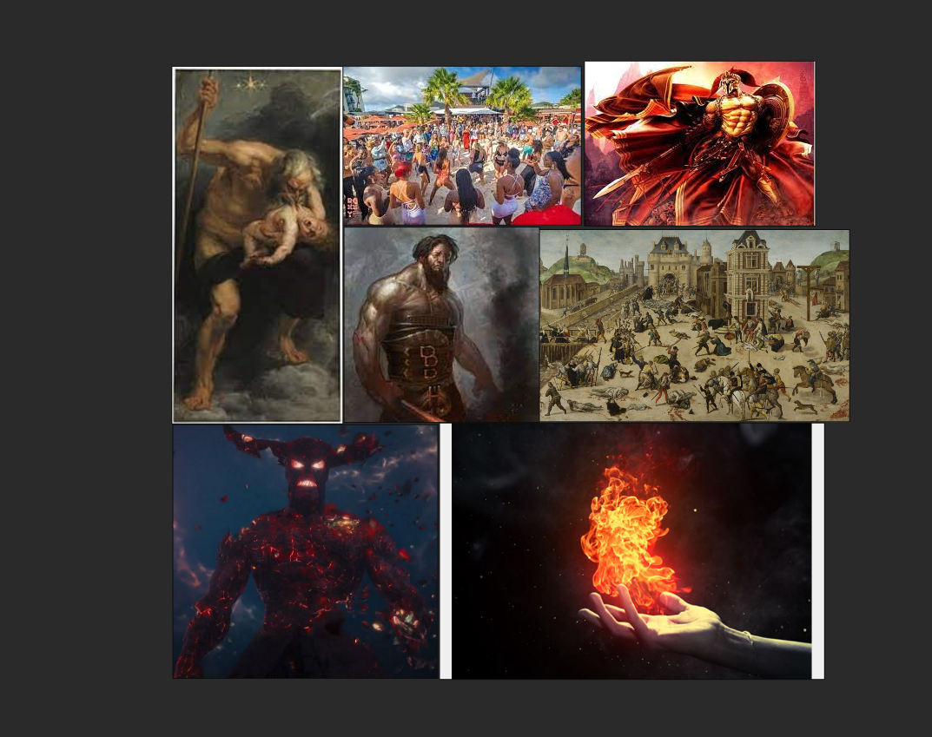

* + Unique Selling Point/s and Key Mechanics

Poseidon loses breath he must return to the sea to breath. The more trash he collects the more fish ammo he gets to fight the enemies. The reward system to cleaning up the beach is that the player gets to do more combat with enemies.

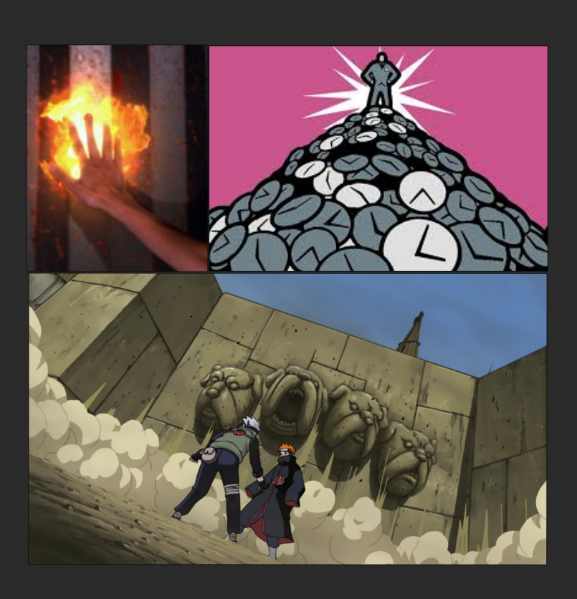

* + Gameplay Summary

The player will go around the beach destroying the army of Ares and Hephaestus till they get to them for the final boss battle.

* + World Summary

Current world setting with a little bit of Greek mythology. The world is being overthrown by the god of war and the god of fire. There is death and destruction when the player sets foot into the environment and is greeted with an army of people guarding reactors powerful enough to take down Olympus.

* + Production Overview

I will be controlling the scope for the game by managing my priorities through a MoSCoW list with the ‘Must’ have is the most important and ‘Could’ have is the least. The work will be split every week of what was taught for the week will be done in the project. The final two weeks for winter vacation will be the play test and the polish for the project. The project will be timed by using sprint sheets. Most of the assets will be utilized from the framework. Some assets that will be needed to purchase will be some beach asset and the final key area that is the mansion. Addition software that will be used for this project will be photoshop and ShareX

* + Player Characteristics Outline

Kronos is tired and he is out for revenge now in the history books he will have the last laugh. He has grown old, but he is not weak and when he is done with his enemies, he can go back to being the rightful ruler of the world.

* + Player Persona

This game will be rewarding for the players who love hack and slash games

This will not be enjoyable for people who like to customize their loadout for their progress in the game.

# Level Design documentation:

* Goals of level & key areas

To eliminate the platoons of Ares and Hephaestus and destroy the world generator to destroy the plan of Ares. The key areas of the level are:

1. The Docks
2. Tiki Bar
3. Surf Shops
4. Armory
5. Mansion (Final Key Area)

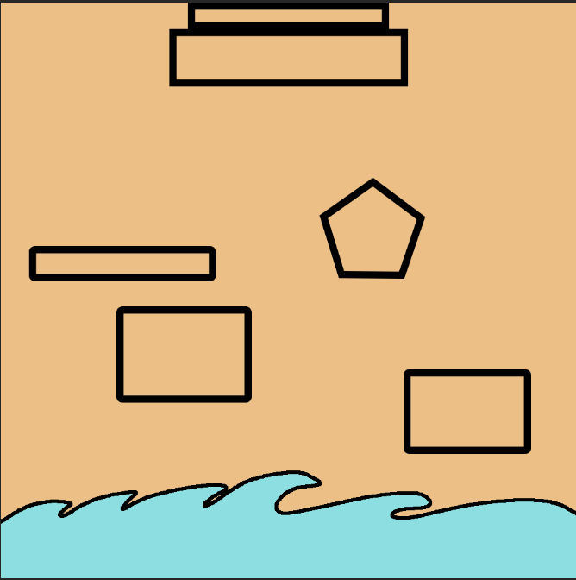

Iteration 1

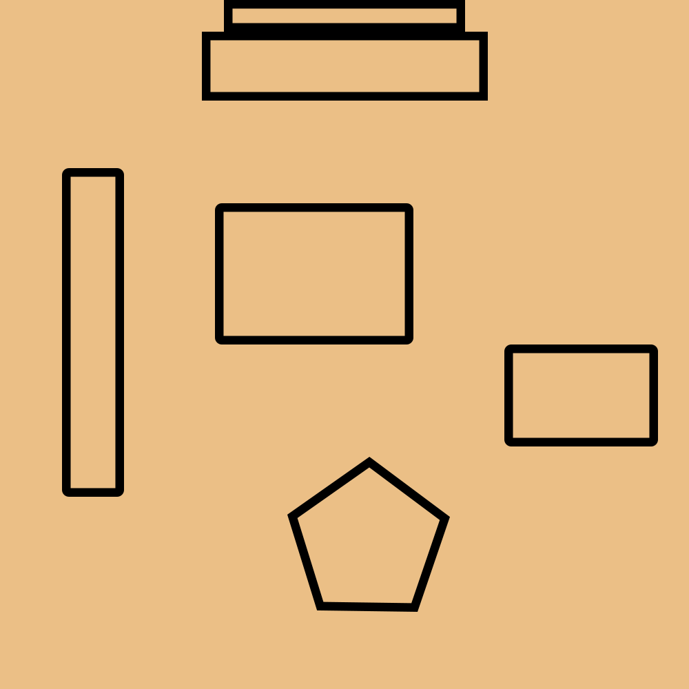

Iteration 2

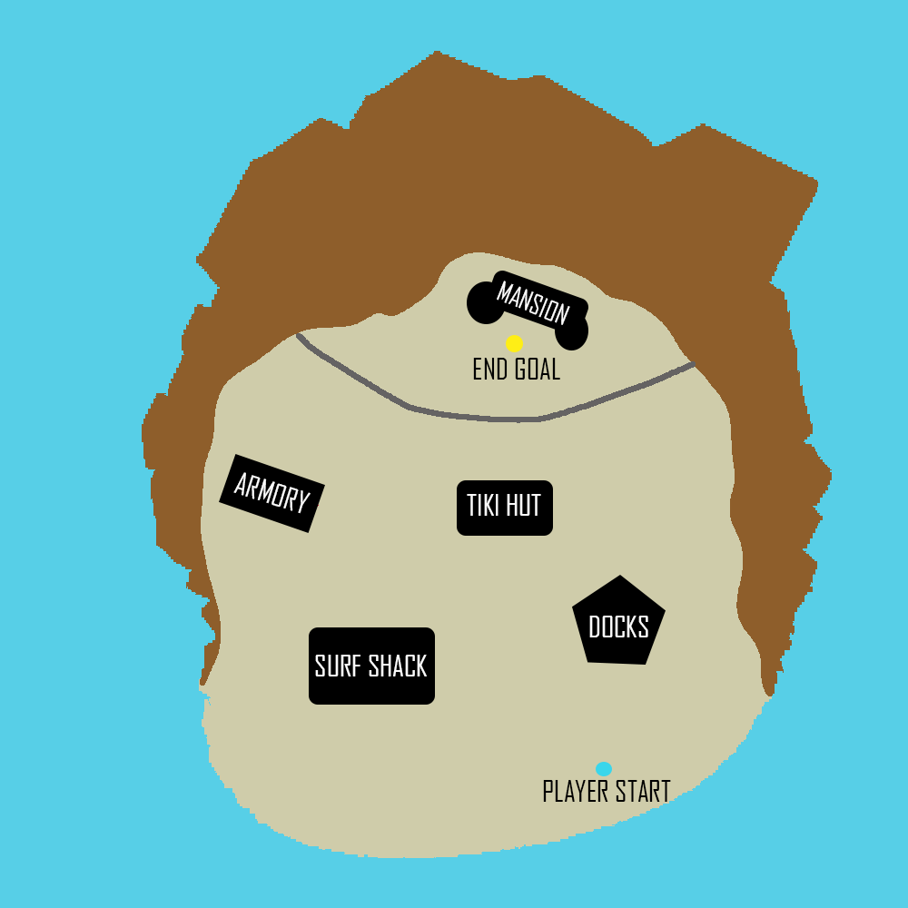

Final Iteration

* Story (How, Why, What)

From the beginning of time Kronos ruled everything, until his son Zeus took that from him and made this world under his control. For millennia he watched and waited for a chance to strike. Now with his sons he will reclaim the world for the giants and bring revenge upon his son. The only problem is that Ares and Hephaestus are now going to kill their father and take the world for themselves. Not this time, he will not allow it, not after this long is he going to let that happen... Never again.

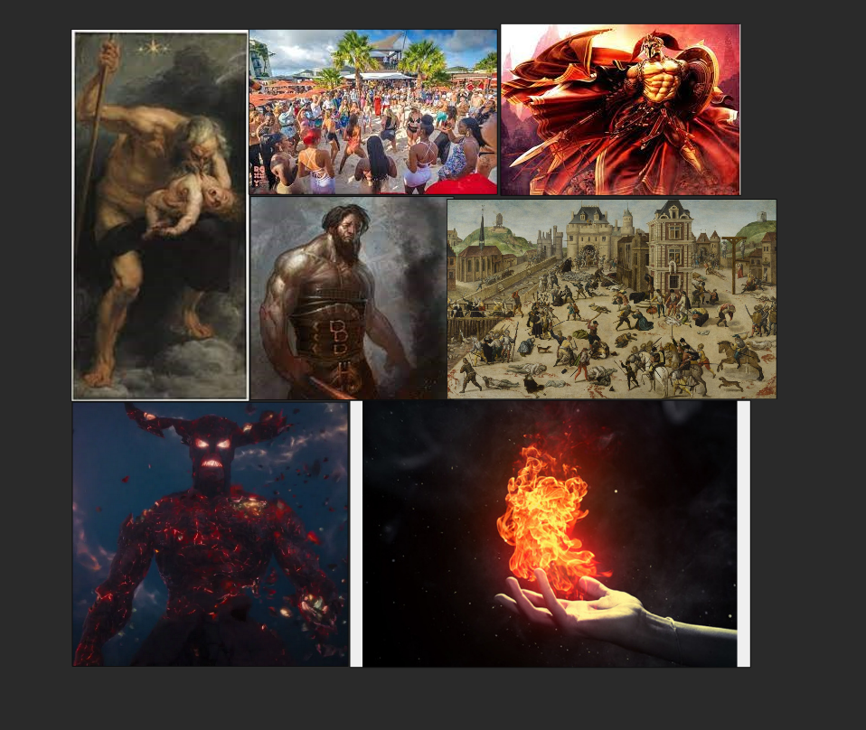

* Focal Point

The focal point for my game is going to be located at the penthouse on the island. This is where Ares and Hephaestus will carry out their plan of killing the other Olympians and Kronos

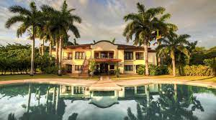

* Visual Development

I wanted the game to be very bright and cartoony and this is Greek mythology we are talking about. The bright and vibrant colors of summer are what I want the players to feel when they play my game.

* Gameplay Influences

Hades was my main influence for this game. The slash and dash style of hades was a lot of fun for me to play around in. I also took inspiration from a previous year’s showcase game for this module. The idea that the character can only stay on land for a limited time will bring a nice balance to the slash style of game.

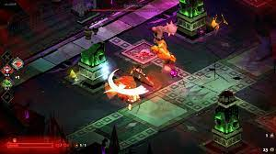

* Color Palette

Since the beach is the setting the palette will be similar to the beach items. Golden sands will cover most of the map. Light blue ocean and small puddles of water for the character to top up their breath.



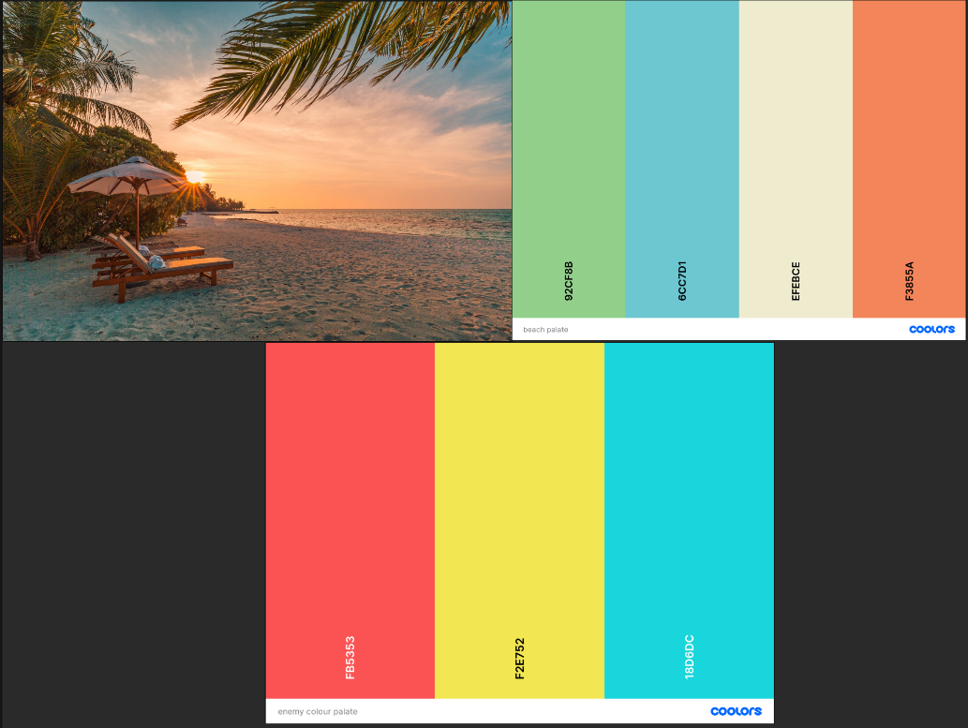

* Lighting

The levels all take place in an afternoon setting. so the lighting will be bright to indicate the game takes place in summertime. The lighting for the level will

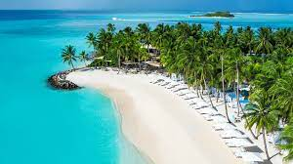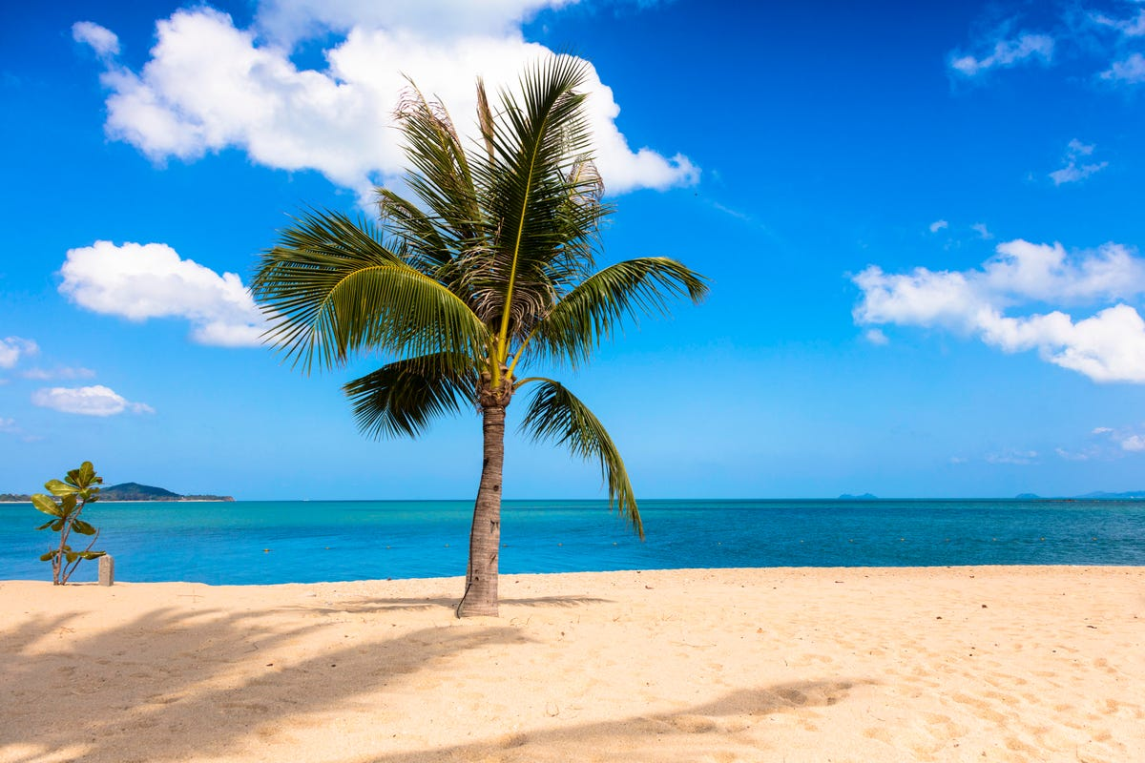

* Asset List

Most of my assets will be for the beach as fillers for meshing. The project will also have people as assets to show the violence that has already been committed by Ares to humans. The most important asset will be the asset for the mansion that is the project's main focal point.

# Level Design Plans

* Focal Point Location

The focal point of the map will be on top of the beach at the beach house where the party is being held. The beach house will be the center top of the map to show its hierarchy of its location and its importance of its position of it being the last part of the level

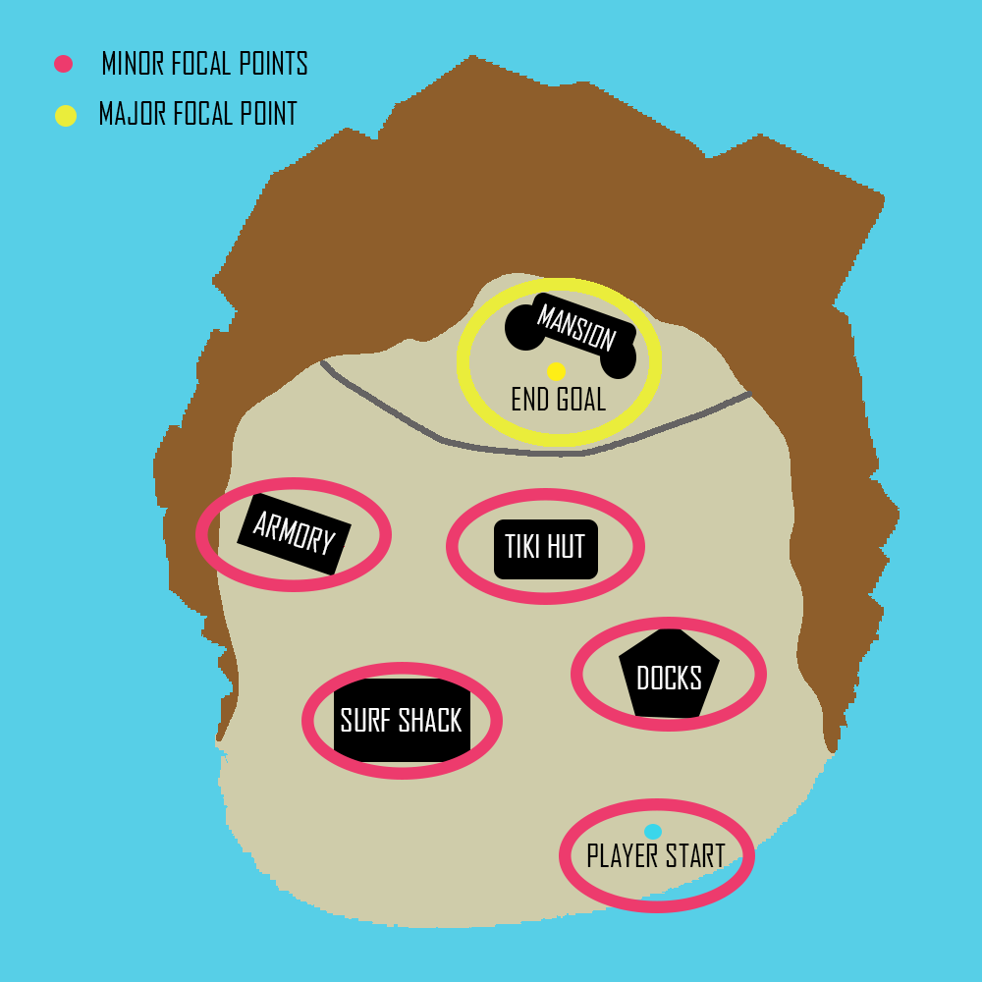

* Focal Point Outlines

The focal points are in these locations and so spread out so that the player can explore the map in their own time. This is an open map so for the minor focal points there is no certain order to how it should be tackled.

* Story Element Locations

The story takes place at the player's start point of the map. The player is spawned into the world, and they will have a little bit of environmental storytelling to show the massacre that has already been committed by the antagonist.

* Critical Path Analysis

There was an original critical path to the level then I made the decision to make the map an open explore region. The reason being is that there is no way that I can creatively think to close an area off for the player while they are in a target zone or a point of interest. Hence the player will spawn at the shore of the beach and will have to move forward then later the other three critical points of interest can be tackled in any manner whatsoever

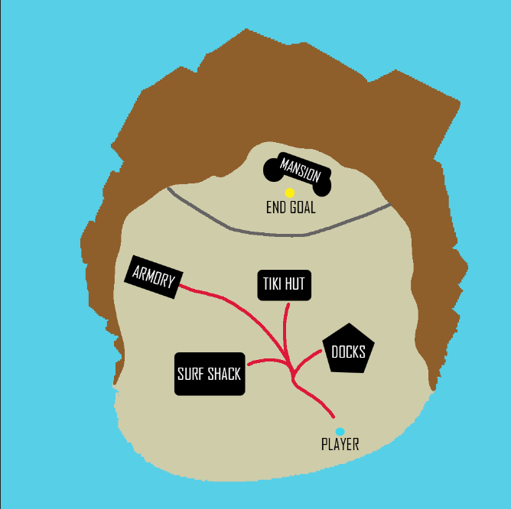

* Enemy Locations

Enemies will be located at locations of interest. At first the character will be spawned into the world and will be introduced to the world by being spawned in front of a mob of enemies. Then the locations of the enemies will be more localized, and the number of enemies will increase in number with the players advancement into the map. There will be random enemies on route to the next location and where the special pickups are placed.

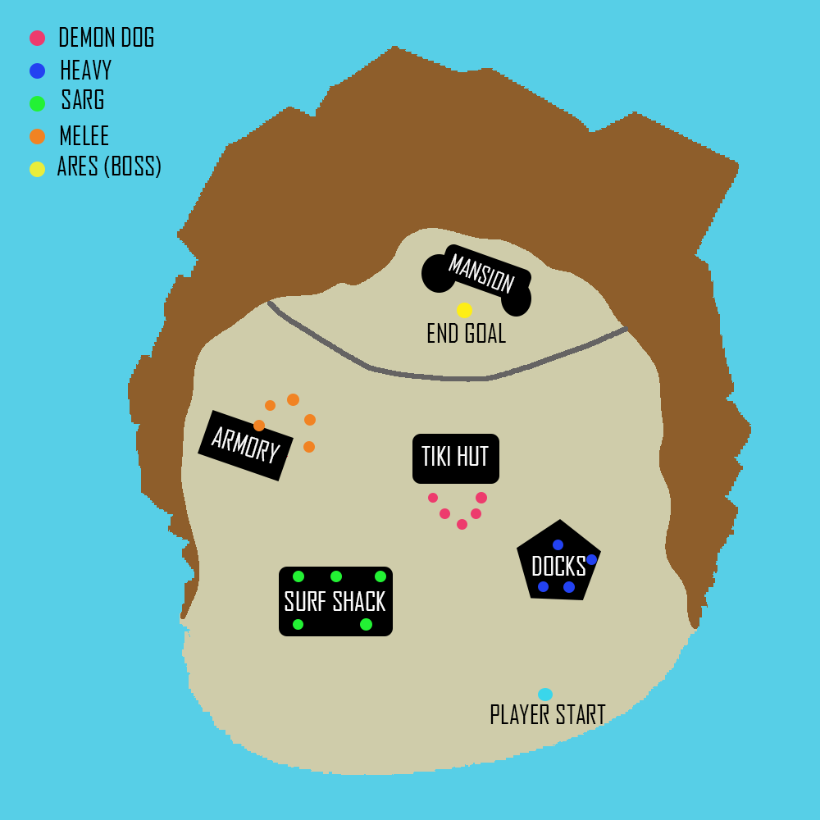

* Pickup Locations

The pickups for this game will be health for the player, its shield and ammo for the guns the player has. The pickups will be put in at the points of interest at the map location. There will also be a big pile of pickups in front of the boss stage.

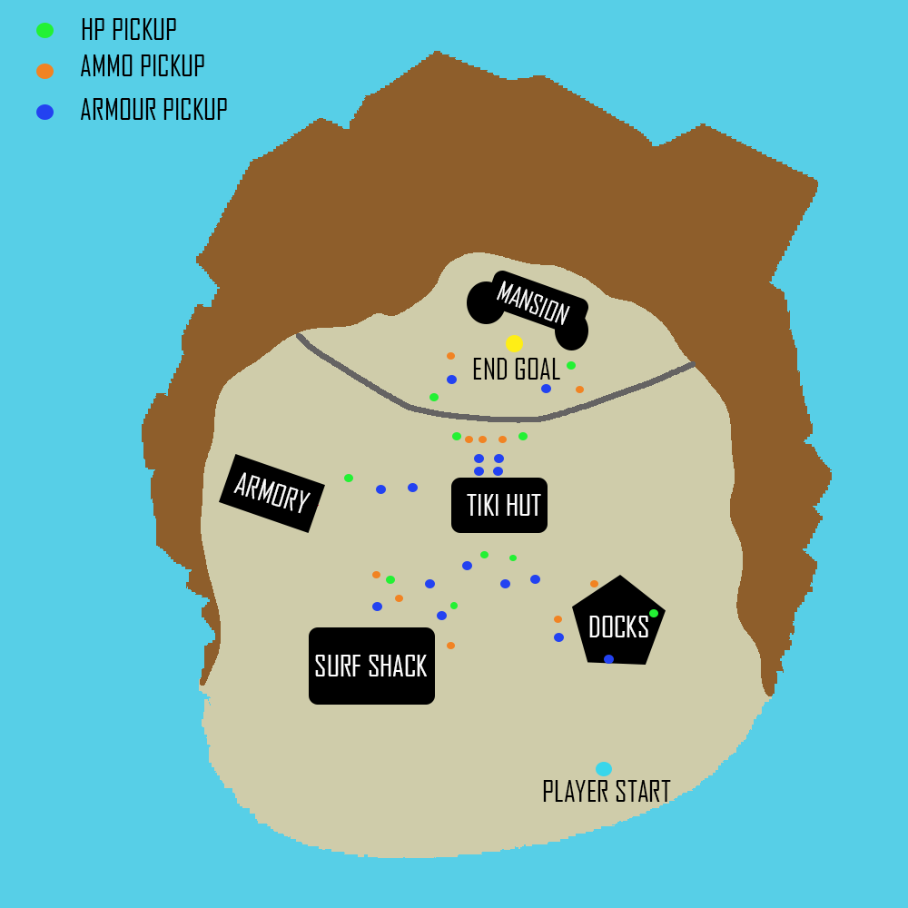

* Weapon Locations

The weapons will always be on the player character from spawn. The player will not receive any new neither will they find any on their way to the boss battle.

* Level Start & Level End Location

The player will start at the beach shore and will be pushed into the first part of the level and then they are free to roam and visit the levels at their own time. They can spend time collecting more power ups for the weapons they have on hand. The players can roam around and when they are ready and when they have all the generators destroyed, they can head to the beach house and finish the map as it is the end level location.

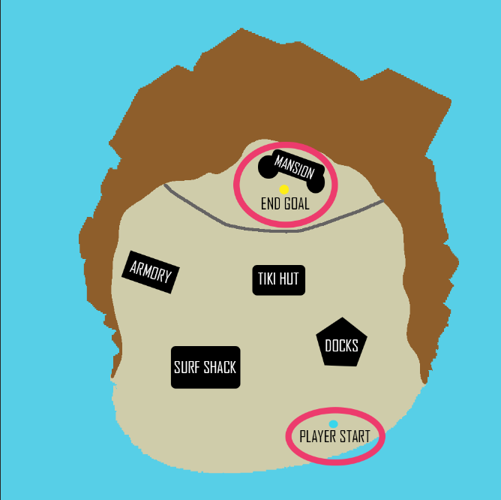

* Level flow

The flow of the level is open as it is free to roam on the island. The player can visit each point of interest at their own time. In the meantime, they can load up ammo, regenerate their health or add more armor. The focal point of the level is on the top of the map

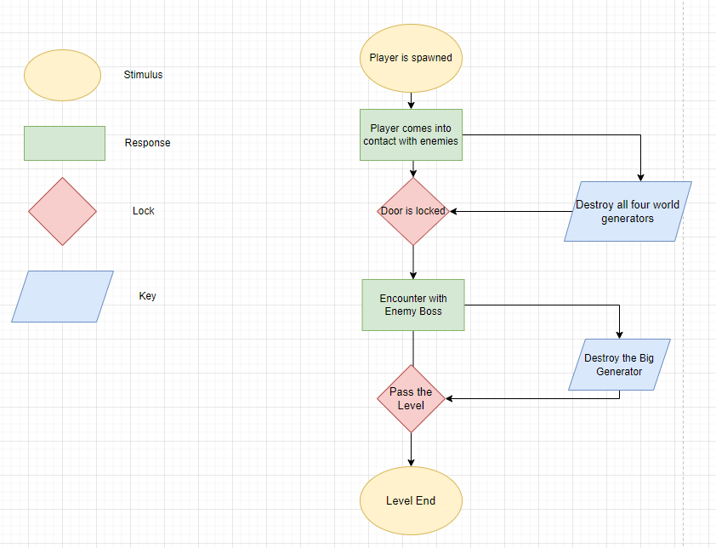

* + Affordance

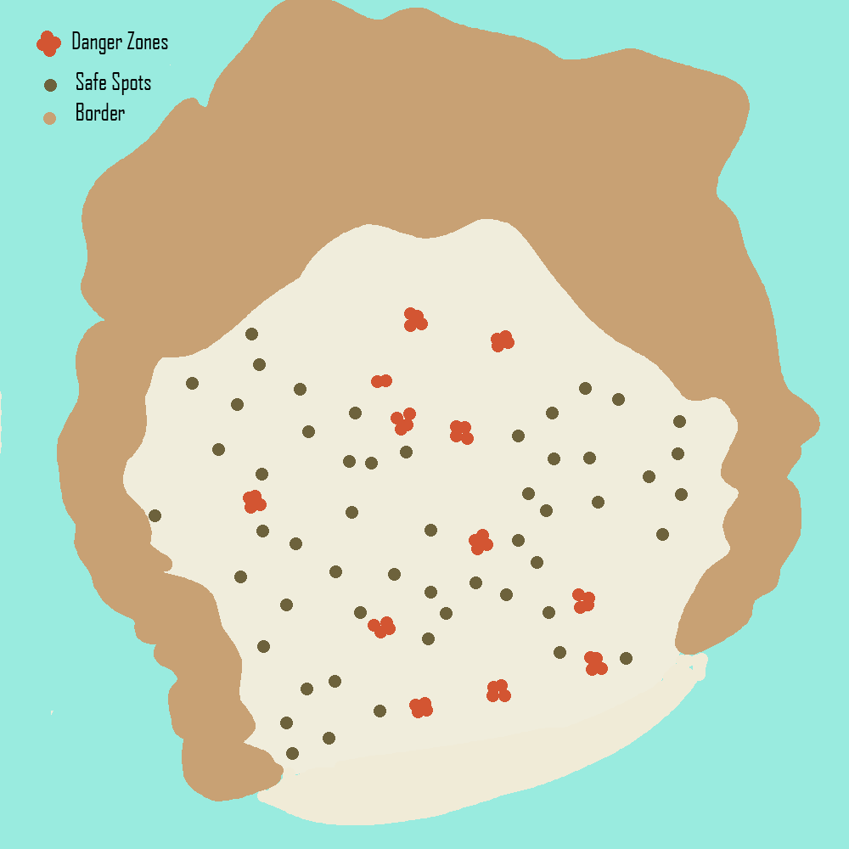

Level Map for Affordance

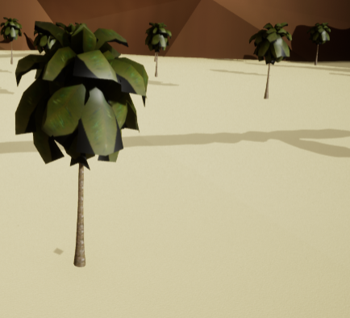

Safe Zones

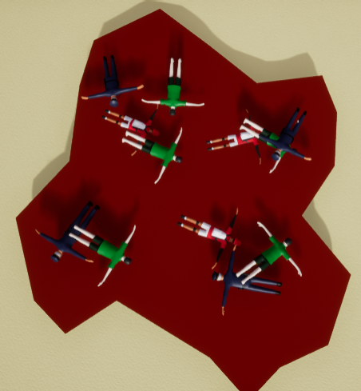

Danger Zones

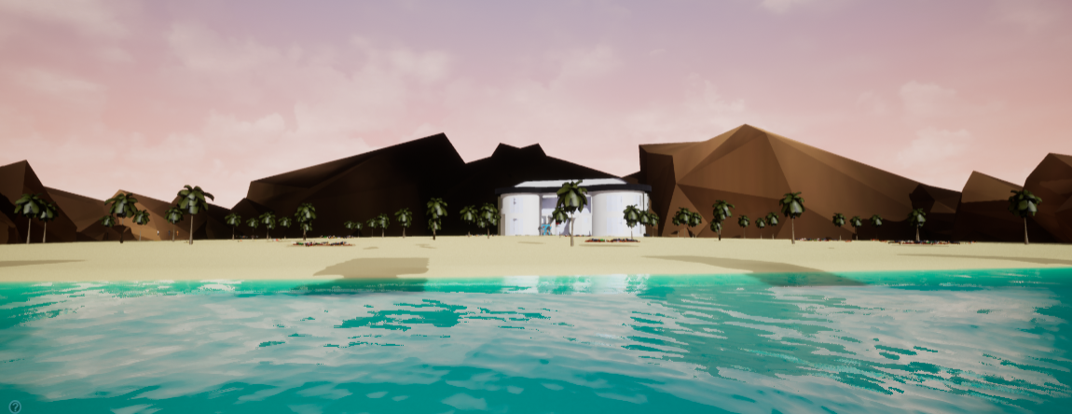

Contrast (Jagger Rocks Indicate Danger/ Blue Water Indicates Safety)

# Player Characters, Controls and Abilities

* Player Controls and Map

The player will use the standard WASD to move around and the left mouse button to fire the gun. To change guns the player must use a scroll wheel to cycle through the guns available and shoot.

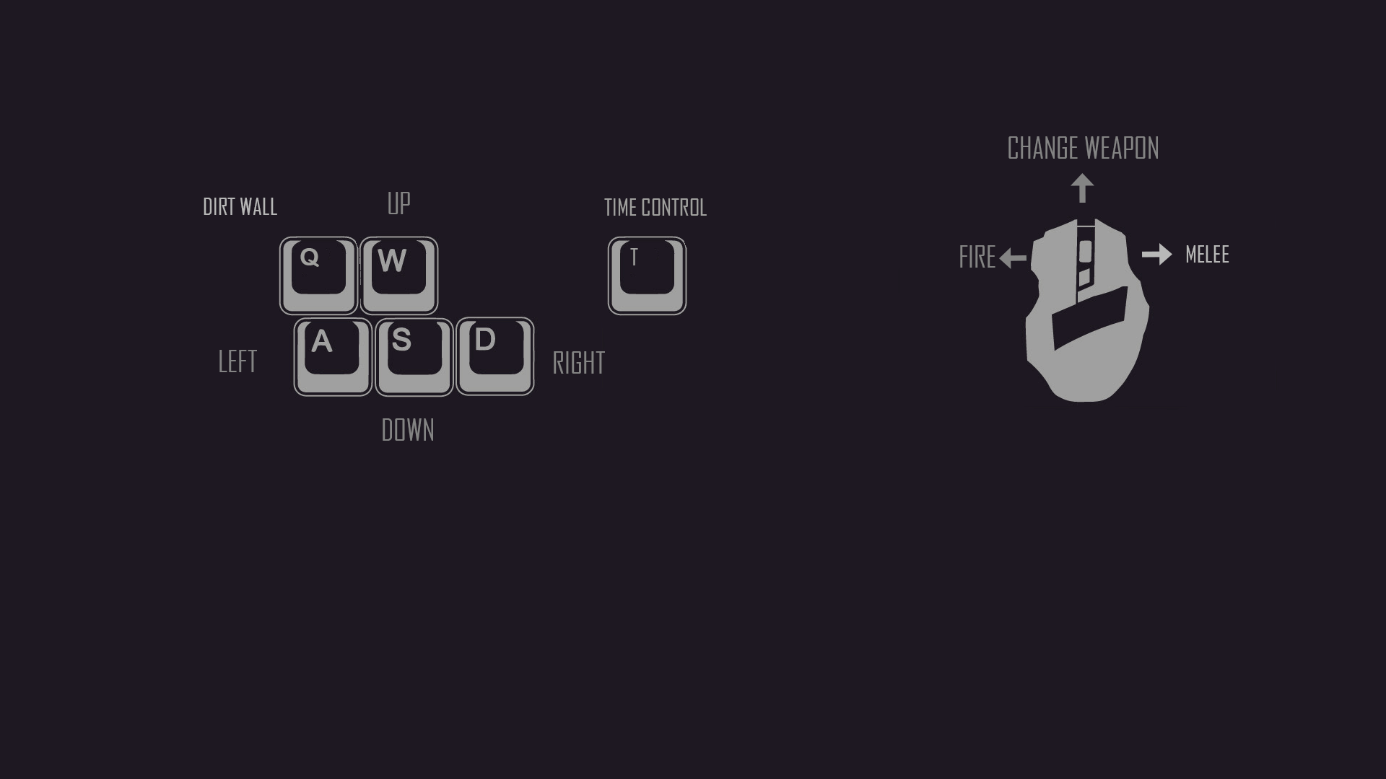

* Player Camera

Will remain the same as the original Teef framework. There will be no reworking for the camera or the way it is angled as I think it my map is an open beach environment, and it will not be necessary to change the camera to fit the environment. The camera is always going to be always focused on the player. The camera does not switch to any other angle and will only have a top-down view.

* Character/s background

The character is an angry Greek titan who is on his way to take matters into his own hands. Enslaved in Tartarus for millennia he finally gets his moment of revenge and takes his rightful place in the universe. As soon as he gets back from the depths of hell, he is betrayed by his sons again as he finds out that Ares and Hephaestus are taking the world for himself.

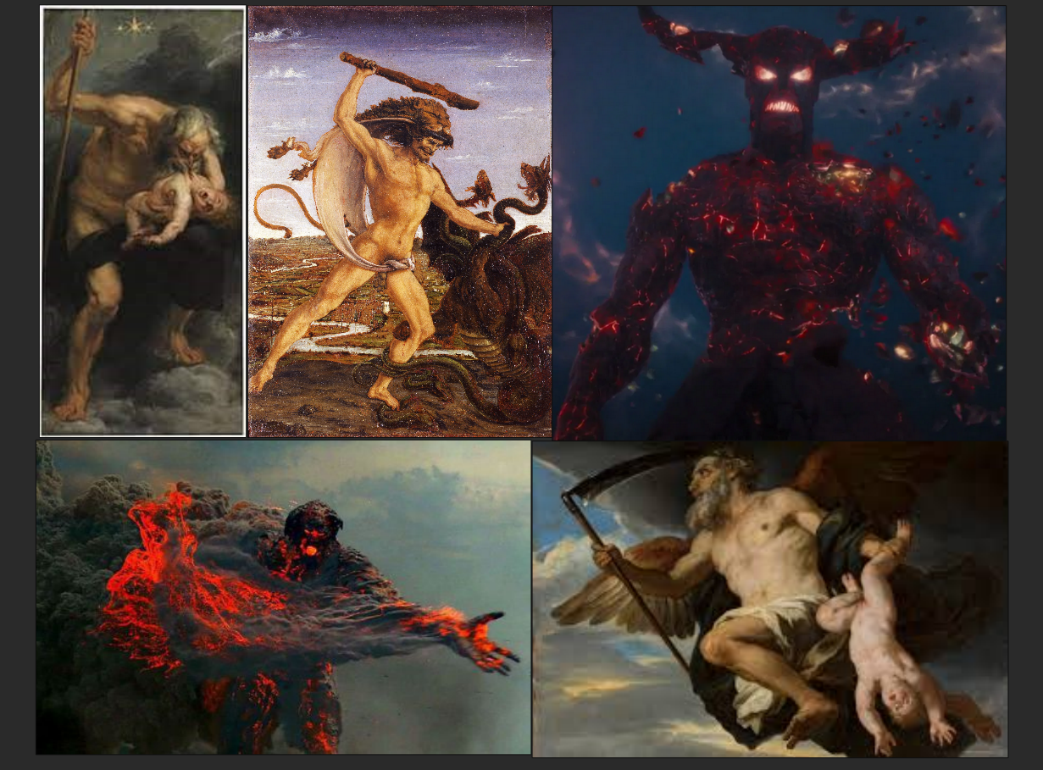

* Character/s Mechanics

The character has three main mechanics they will use to win the game. The first mechanic will be to slow down time. With time control, the player will use this to avoid a bullet hell or direct attack or to position themselves for a better attack. The second mechanic for the player will be to have an earth wall. The earth wall will provide defense for the player while being up for a certain health. The third mechanic is to have pyrokinesis. With this mechanic the player character has flames coming out of their hands. This will be on a cool down like the others and will deal maximum damage for a brief time.

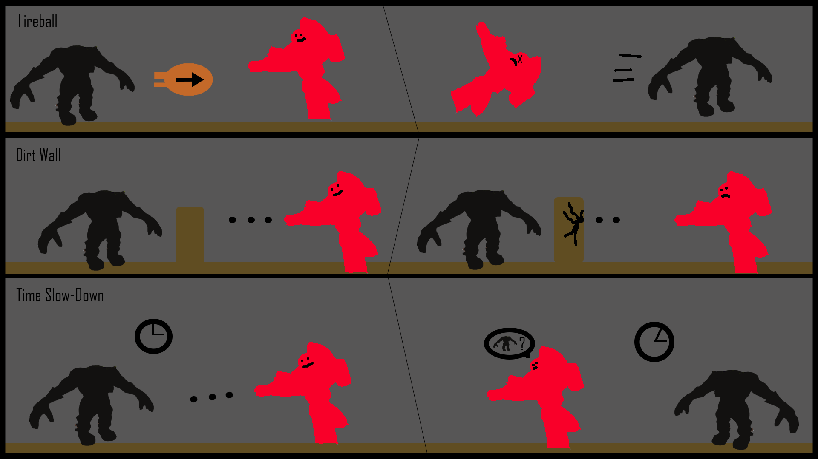

* Character/s statistics
  + Current Amount

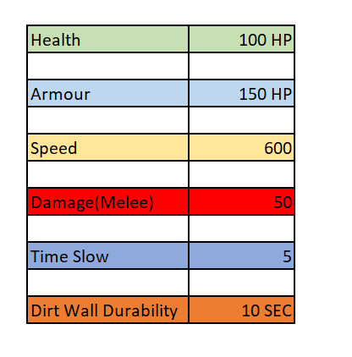

* + Max Amount



* Character/s Weapon Loadout
  + Default Weapons

The player will spawn with three guns by default. They will use these guns to play the level and defeat the boss, the three guns are :

* Styx
* Gaia
* Atlas

The second is the melee for the player character that will do a certain amount of damage to the enemy.

# Weapons and Pickups

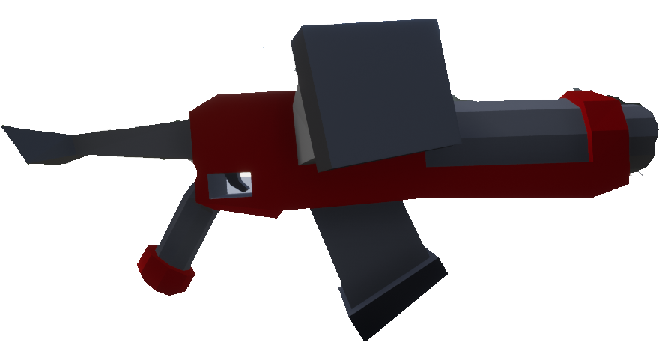

STYX

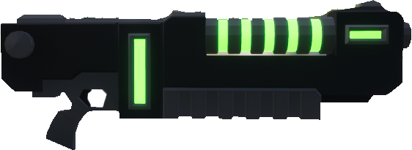

GAIA

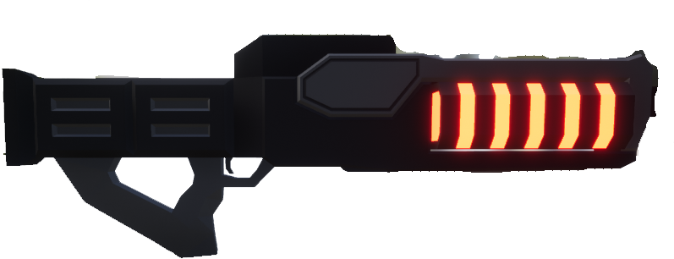

ATLAS

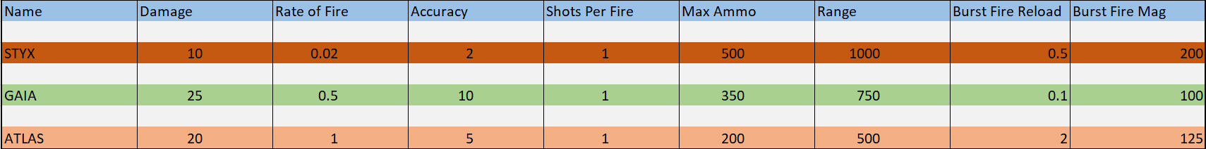Weapon Stats

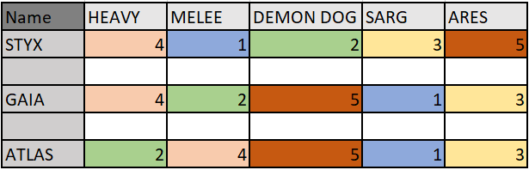

Gun Quick Point (1-very good, 5-worst)

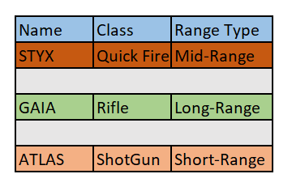

Gun Class Type

# Game Conditions

* How do you win?

To win the game the player must go around the map destroying all small generators which are being guarded by guards at their post. Finally, the player will be put into a boss fight and then will have to destroy the final generator.

* How do you lose?

The two ways a player can lose the game are by not completing the level and letting Ares take over the world. The player can avoid this by destroying the small generators and destroying the army of Ares.

* Can you die?

The only way the player can die is to lose health. Once the health bar hits zero, the player is automatically taken out of the map, and they would have to start from the beginning and complete the level.

# Rewards and Progress

* Achievements based on player type such as collector, explorer, killer.

The game rewards the player that leans more into the action genre that would define their playstyle as a killer. The satisfaction to take down a multitude of enemies is what a killer type would like as an achievement.

* Score such as multipliers, kills, kill count, collection based.

The score will be based on the type of enemy that the player defeats. Once the player kills an enemy, they will receive some points as a reward. This can be used as a gauge to check how good they are at completing the game or how long they can stay alive with enemies around them.

* Upgrades such as character / weapon enhancements / unlocks.

The player will not receive any upgrades as they will not be using guns to fight enemies and only fire power. As the character is a Greek titan that once ruled the universe, I would find it to do injustice to the character.

* Key Drops / Usage

There will be HP drops around the map as well as some powerups drop for the player characters fire power. The player can utilize these drops to then progress in the map and complete each key area. The player can also choose to save the powerups for the final boss battle also heal up before the final boss.



* Choke Points

The choke points for the game will be located where the world generators are. The single spot of attack where the enemies will convene to attack the player while the player tries to damage the generator. In total there are four choke points located in the key areas of the map.



* Enemy Density

The enemies will be scattered around the map mostly. The denser spots in the map will be the spots where the enemies will be guarding the generators. The first fight the player is put into will be a small one, where they will learn to use their character abilities. Then the player can choose how they progress in the map, searching for locations of interest or looking for pickups.

* Level Pacing with use of environment, enemies and pickups

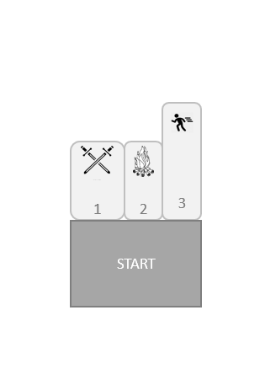

Start

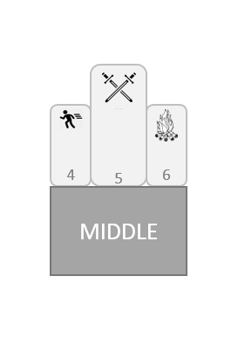

Middle

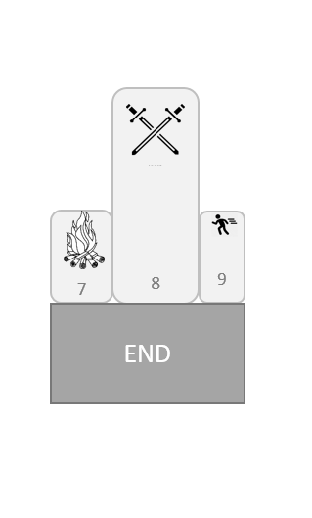

End

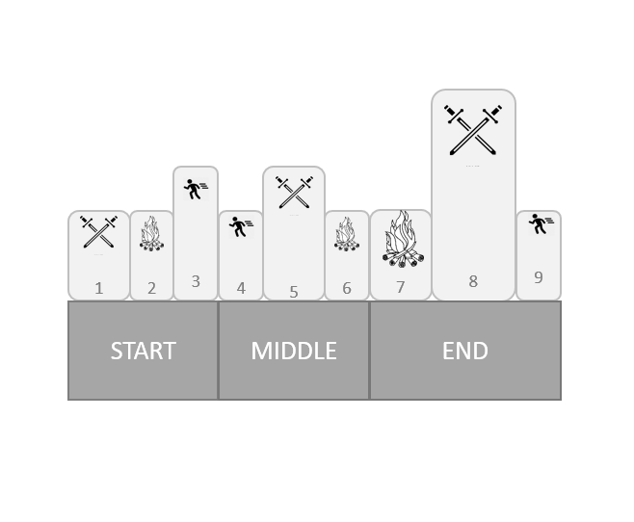

Beats

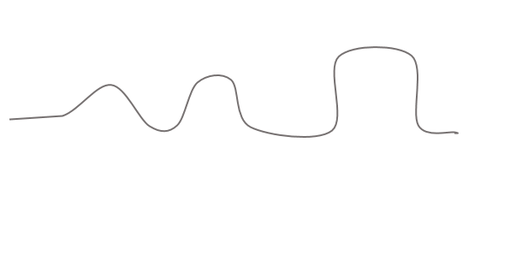

Pacing

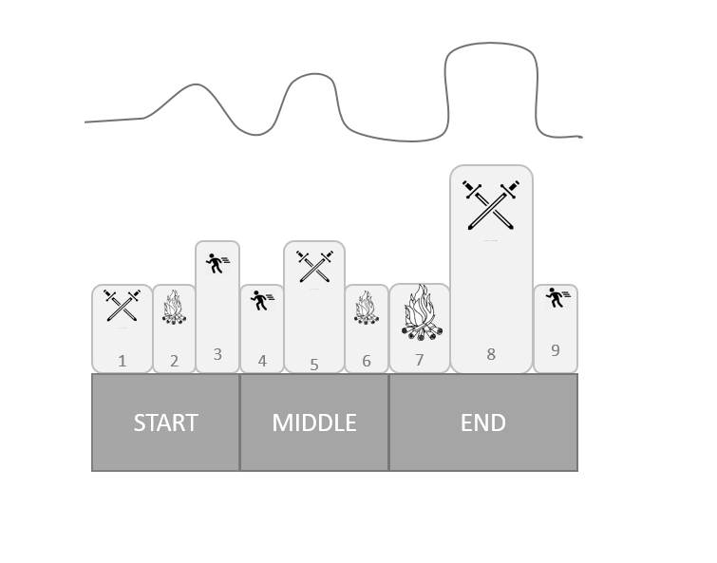

Beats and Pacing

# Enemy Design

* Enemy Physics

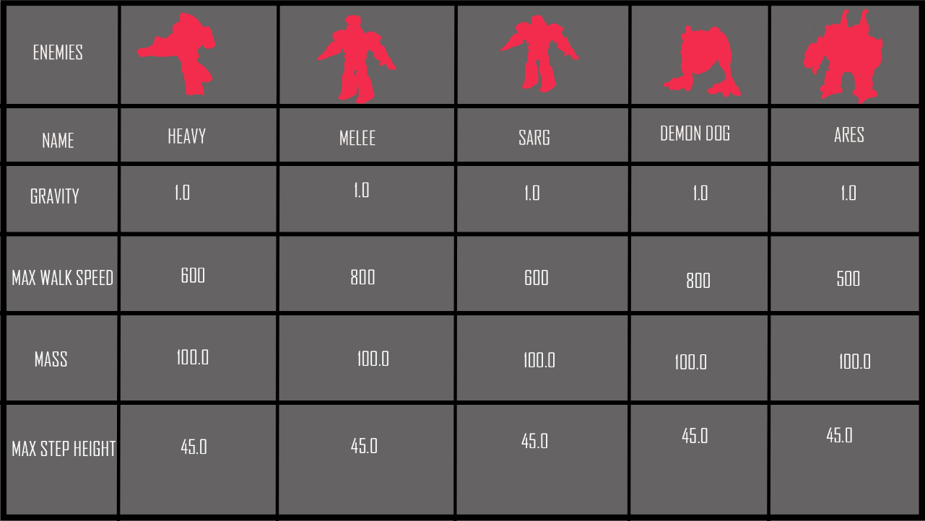

* Enemy Behaviour characteristics

All the enemies have similar behavior. There are four basic states that are shared between the A.I, They are:

* Patrol
* Chase
* Attack
* Idle

The states change according to how the player reacts to the enemies. The patrol state will make the enemy walk around to the target point that has been placed. The enemies will move back and forth between the target points. On spotting the player the enemies will go into attack mode. When the player moves back away from the enemy, the enemy goes into chase mode and will follow the player across the map as long as the player is within the line of sight. The enemy will go into idle state when they have no waypoint and or when there is no player in its line of sight.

* Enemy Guns

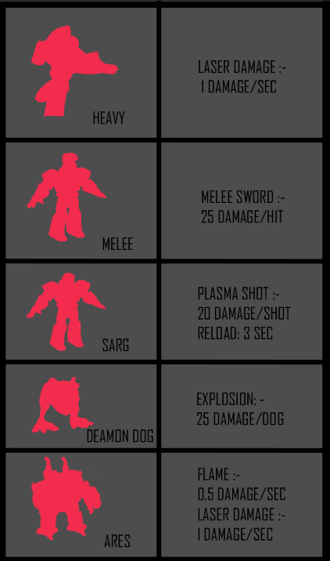

* Enemy Theme

Heavy- Tank Soldier Class

Melee – Standard Soldier Class

Demon Dog – Runner Class

Sarg – Sniper Class

Boss – Standard Boss Class

* Enemy Stats

